# Victoria Crimes Trends

The study is for the period of September 2012 to September 2021. Various data mining, scrapping, cleansing, data visualisation techniques and statistical calculations had been applied to ensure the findings are consistent and best interpreted the government crime data.

* 1. **Kernel Density Estimation (KDE)**

In statistics, Kernel Density Estimation (KDE) is a non-parametric way to estimate the Probability Density Function (PDF) of a random variable.

This study applied Gaussian kernels with automatic bandwidth determination based on “scotts_factor” formula: *n**(-1./(d+4))*.

(D.W. Scott, “Multivariate Density Estimation: Theory, Practice, and Visualization”, John Wiley & Sons, New York, Chicester, 1992.)

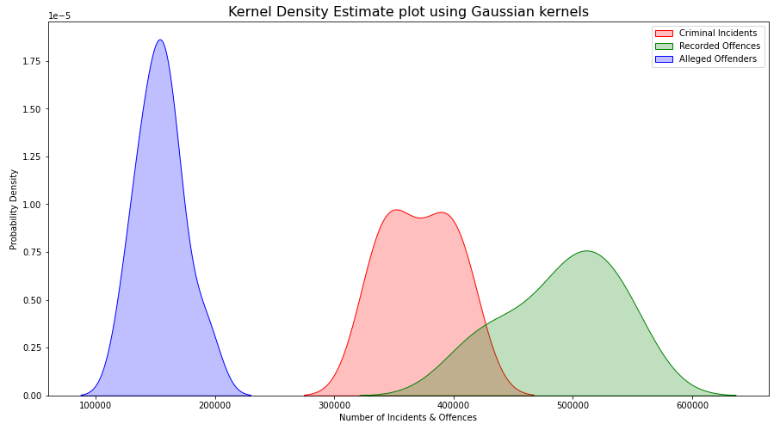

The graph visualised the probably density for Criminal Incidents, Recorded Offences and Alleged Offenders based on the ten years period.

The numbers of Alleged Offenders Incidents were sharply increased within the bell curve, while Criminal Incidents were steady increased and Recorded Offences were slowly increased with some outliers.

* 1. **Criminal Incidents, Recorded Offences and Alleged Offenders**

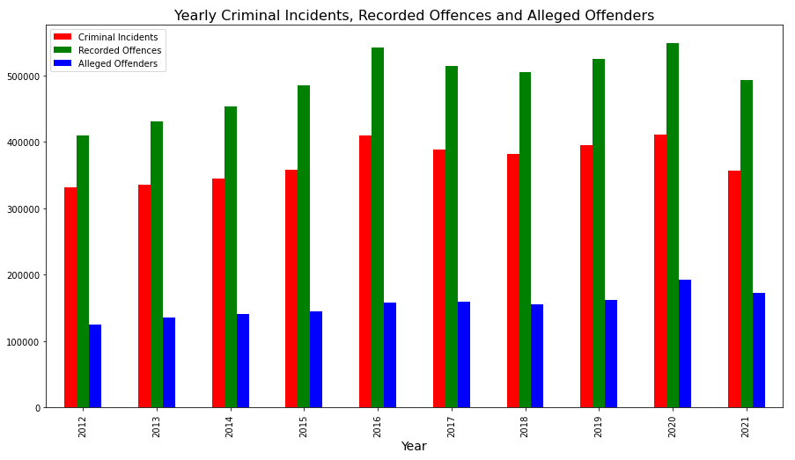

The graph above illustrates the yearly crimes data for Criminal Incidents, Alleged Offenders and Recorded Offences.

The yearly data volume changes had been calculated in percentage as shown in the table below:

|  |  |  |  |  |
| --- | --- | --- | --- | --- |
| Year | Criminal Incidents | Recorded Offences | Alleged Offenders | Population |
| 2012 | (Baseline) | (Baseline) | (Baseline) | (Baseline) |
| 2013 | 0.012099 | 0.054790 | 0.090524 | 0.017587 |
| 2014 | 0.029842 | 0.052259 | 0.040208 | 0.024388 |
| 2015 | 0.039363 | 0.068144 | 0.028308 | 0.018456 |
| 2016 | 0.141908 | 0.116527 | 0.084495 | 0.021263 |
| 2017 | -0.051259 | -0.050605 | 0.008406 | 0.018048 |
| 2018 | -0.018528 | -0.018061 | -0.020907 | 0.029002 |
| 2019 | 0.035609 | 0.040722 | 0.043626 | 0.015371 |
| 2020 | 0.040523 | 0.044216 | 0.189915 | 0.021673 |
| 2021 | -0.131986 | -0.100593 | -0.105169 | -0.007842 |

The finding depicts that:

* Year 2016 had a significant increase in Criminal Incidents with 0.14% and Recorded Offences with 0.12% (round up to the nearest two digits).
* Year 2020 also had a big jump in the number of Alleged Offenders incidents with 0.19%.
  1. **Ten Years Overview Crime Statistics**

Crimes data had been calculate for its mean, standard deviation with minimum, maximum, first quartile, second quartile (median) and third quartile.

* The first quartile (Q1) is defined as the middle number between the smallest number (minimum) and the median of the data set. It is also known as the lower or 25th empirical quartile, as 25% of the data is below this point.
* The second quartile (Q2) is the median of a data set; thus 50% of the data lies below this point.
* The third quartile (Q3) is the middle value between the median and the highest value (maximum) of the data set. It is known as the upper or 75th empirical quartile, as 75% of the data lies below this point

|  |  |  |  |  |  |  |  |
| --- | --- | --- | --- | --- | --- | --- | --- |
|  | Criminal Incidents | Criminal Incidents  Rate | Recorded Offences | Recorded Offences  Rate | Alleged Offenders | Alleged Offenders  Rate | Total |
| count  (number of years) | 10.0 | 10.0 | 10.0 | 10.0 | 10.0 | 10.0 | 10.0 |
| mean | 371,030.6 | 23,614.45 | 490,620.5 | 31,240.43 | 154,560.7 | 9,955.12 | 1,016,211.8 |
| standard deviation | 29,772.09 | 1,304.28 | 46,454.24 | 1,856.8 | 19,499.59 | 713.94 | 92,297.04 |
| min | 330,923.0 | 21,248.43 | 408,983.0 | 28,472.58 | 124,409.0 | 8,828.47 | 864,315.0 |
| 1st Quartile - 25% | 347,828.75 | 23,052.66 | 461,668.25 | 29,749.42 | 142,124.75 | 9,619.61 | 952,109.25 |
| 2nd Quartile - 50% | 369,846.0 | 23,453.34 | 498,991.0 | 31,448.79 | 156,385.5 | 9,827.37 | 1,031,891.5 |
| 3rd Quartile - 75% | 393,172.5 | 24,177.39 | 522,423.75 | 32,315.31 | 161,301.75 | 10,256.3 | 1,076,898.0 |
| max | 410,764.0 | 26,304.42 | 548,465.0 | 34,796.25 | 192,965.0 | 11,485.34 | 1,152,194.0 |

The finding above demonstrates:

* Year 2016 has the *highest* Crime Incidents (26,304 incidents) and Recorded Offences (34,796 offences) rate per 100,000 population.
* Year 2021 has *lowest* Crime Incidents (21,248.43) rate per 100,000 population.
  1. **Visualised Victoria Crime Trends by Police Service Region**

Several bar graphs had been drawn for each type of crime to visualise the number of crime incidents and offences occurred in the last ten years, with their associate rates per 100,000 population that recorded by the local’s police service region.

The four police service regions are: North West Metropolitan (blue), Eastern (green), Southern Metropolitan (orange) and Western (red).

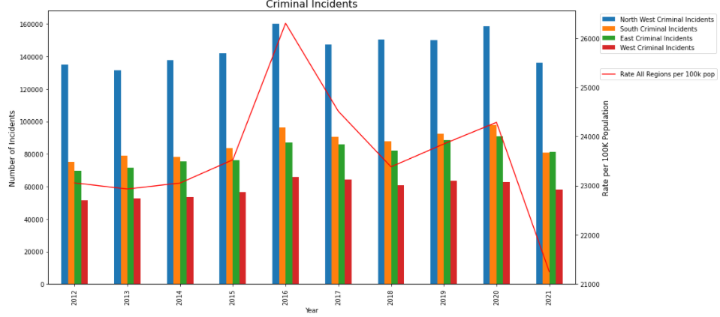

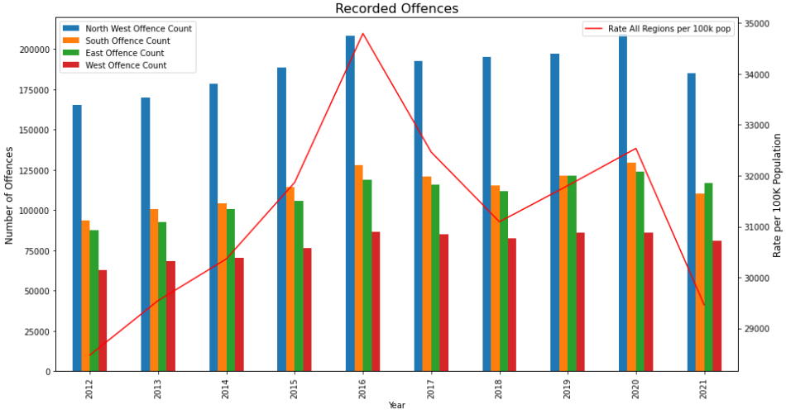

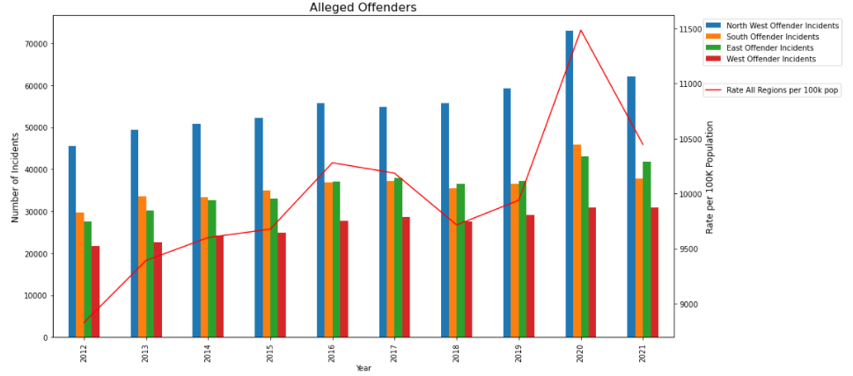

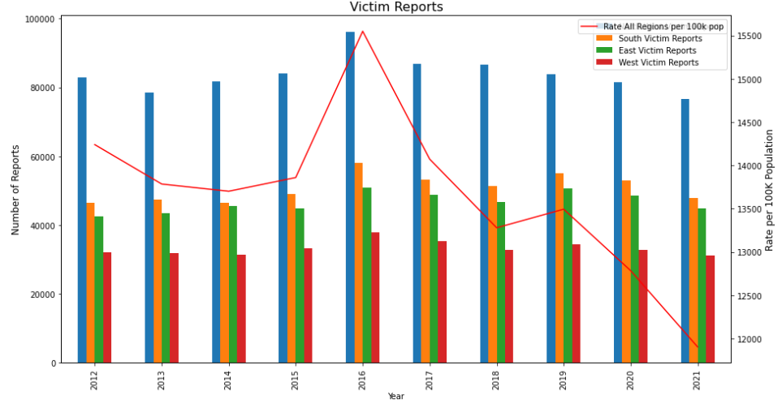

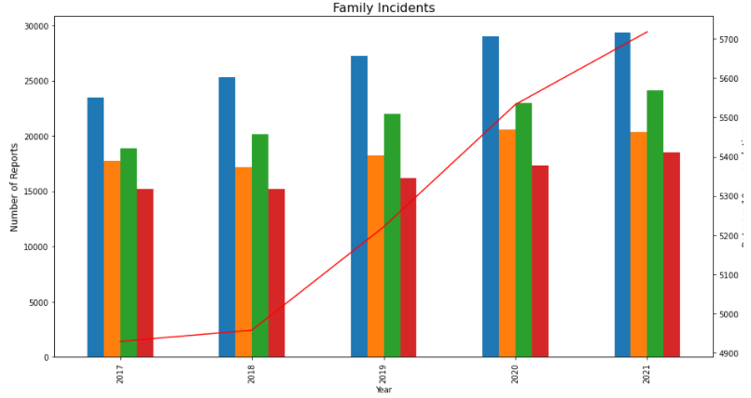

The trend lines of the crime rate per 100,000 population for all crimes are decreasing between 2020 to 2021, except Family Incidents. This could be due to various local community events as highlighted in the previous sections of this report.

* 1. **Yearly Changes of Crime by Police Service Region**

The table below illustrates the percentage of changes of the number of incidents and offences that occurred in the four police regions.

|  |  |  |  |
| --- | --- | --- | --- |
| Types | Police Service Region | Highest In Year | Highest Yearly Percentage Change |
| Criminal Incidents | Southern Metro | 2013, 2015, 2020 | •0.05, •0.07, •0.06 |
| East | 2014, 2017, 2019 | •0.05, -0.01, •0.08 |
| Recorded Offence | West | 2013, 2016, 2017, 2021 | •0.09, •0.13, -0.02, -0.06 |
| Alleged Offender Incidents | Southern Metro | 2013, 2015, 2020 | •0.13, •0.42, •0.26 |
| Victim Reports | East | 2013, 2014, 2017, 2019 | •0.02, •0.05, -0.04, •0.08 |
| Family Incidents | North West Metro | 2018 | •0.08 |
| East | 2019 | •0.09 |
| Southern Metro | 2020 | •0.13 |
| West | 2021 | •0.07 |

It is observed that:

* Year 2019, *East* region is taking the lead in increasing in Crime Incidents (•0.06), Victim Reports (•0.08) and Family Incidents (•0.09) compares to other Police Service regions.
* Year 2020, *Southern Metropolitan* region is having the highest increase in the Crime Incidents (•0.06), Alleged Offender Incidents (•0.26) and Family Incidents (•0.13) compares to other Police Service regions.

* 1. **Victoria Crimes Data Maps**

Interactive maps had been produced to show the ten years average of Victoria crimes volume based on the local government boundaries with the utilization of the python geopanda library and geometry data from the government website. Summary average data of crimes will be displayed when a colored section of the map is selected. The maps had been created by using Jupyter notebooks, which can be located on [github](https://github.com/antoinetteboyle/Project-1).

Below are the snapshot samples of the map:

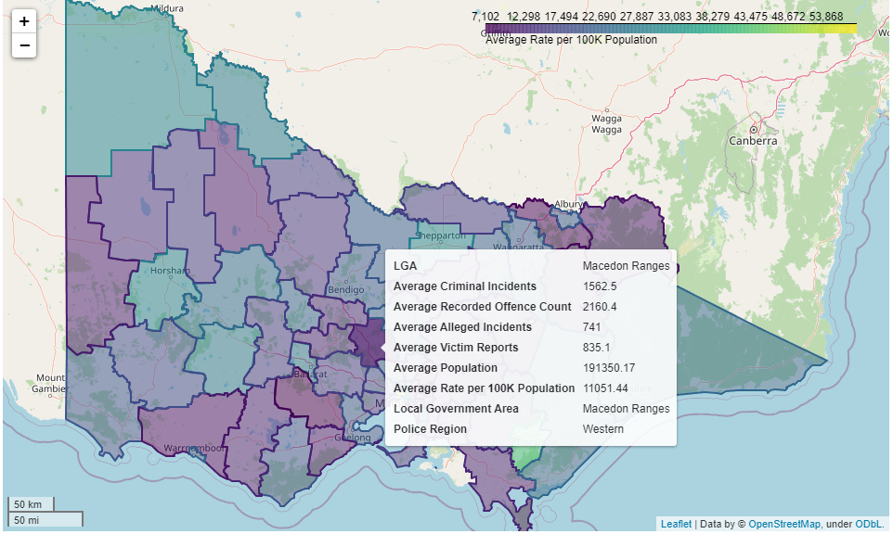

Each local government area (sometimes referred as Suburb or LGA) is coloured code. The ten year average volume of crimes is matching with the colour code, the higher crime rate is the lighter in colour. The colour is scaling from dark purple to green and then bright light yellow.

Another map was also produced for the crimes that grouped by police region. The map’s colour code is for the police service region rather than the density of crimes.

